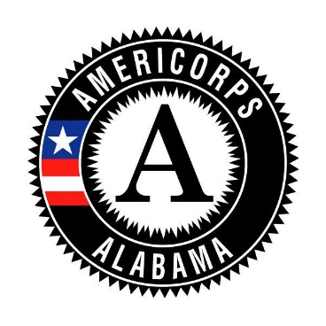
ALABAMA AMERICORPS
Governor’s Office of Volunteer Services

Member Management Module
Member Interview

Member Name: |  |  |  |  | Date:
Member Title:
Program Name: |  |  |  | Program Year:
GOVS Staff Conducting Interview:

You are not required to ask all of the questions below. You may skip questions or ask questions not on this list.

ORIENTATION/SERVICE:
- What year of service are you currently serving? |  |  |  | 1ST 2ND 3RD 4TH
- How did you become interested in AmeriCorps?
(ONLY 3 QUESTION) PRE-SERVICE ORIENTATION QUESTIONS-NOT NECESSARY FOR EVERY INTERVIEW
- Prior to your start date, did you participate in pre-service orientation? |  |  |  |  |  |  |  | Yes No
 | - What activities did you participate in during pre-service orientation?
 | - Who did you report to during pre-service orientation?
 | - How long did pre-service orientation last? start/finish
 | - Was an offer of service contingent upon satisfactorily completing pre-service orientation? Yes No
 | - Was pre-service orientation considered a probationary period? |  |  |  |  | Yes No

- Did you attend orientation prior to beginning your service? |  |  |  | Yes No Examples of orientation activities:
- Do you feel you were adequately oriented for this service role and is it what you expected? |  |  |  |  |  |  | Yes No
- What was the most valuable/useful part of orientation?
- Was there anything that you wish would have been presented at orientation that wasn’t? |  |  |  |  |  | Yes No
- Were you provided with a clear Position Description? |  |  | Yes No
- Do you have access to the materials and equipment needed to perform your service? |  |  |  |  | Yes No

TRAINING:
- Do you receive regular training to support your service? |  |  | Yes No Ask for and list examples.
- How often do you receive training? |  | Monthly, every 2 months, etc.
- Are there any other trainings that you would like to receive? |  |  |  | Yes No Ask for and list examples.

REGULATIONS/PROGRAM:
- Can you list a few of the AmeriCorps Prohibited Activities (AC)? |  |  |  |  | Yes No
 | Activities member listed:
 | If they cannot list any, go over some of the activities.
- Are you familiar with your programs’ grievance procedure and did you receive a copy? |  |  |  |  |  |  |  | Yes No
 | Specifically listen for who they are to contact (chain of command)
- Do you ever serve in a clerical/administrative role at your site? |  | Yes If yes, ask when and how often. No
- Do you fill in for other staff when they are out sick or on vacation? |  |  | Yes If yes, ask when and how often. No
- Do you feel you are adequately supervised and that your needs are being met? |  |  |  |  |  | Yes No
 | If no, ask why and what improvements they feel could be made.
- Can you comfortably go to program staff if you are having a problem? |  |  |  | Yes No
 | If no, ask why and what improvements they feel could be made.
- What kinds of support do you receive to perform your service?

MEMBER EXPERIENCE:
- Have you connected with other AmeriCorps members in the area? |  |  |  |  |  |  |  | Yes No
- What is your overall impression of this AmeriCorps program?
- Have you enjoyed your service experience in this program thus far? |  |  |  |  |  |  |  | Yes No If no, ask why.
- Would you recommend this AmeriCorps program? |  |  |  |  | Yes No If no, ask why.
- Do you feel that your AmeriCorps program has benefited from your service as much as it could have?
 | Yes No If no, ask why.
- Is there anything we can do to help you get better connected/feel more supported? |  |  |  |  |  |  |  |  |  |  |  | Yes If yes, what? No
- What accomplishments are you most proud of?
- What is the best part of serving as an AmeriCorps member?
- Is there anything you wish was different? |  |  | Yes If yes, ask what? No
- Is your program helping you plan for life after AmeriCorps? |  |  |  |  |  | Yes No
- Are you aware of AmeriCorps Alums and Employers of National Service? |  |  |  |  |  |  |  |  | Yes No If no, provide info.

- Is there anything else you would like to tell us?

Thank the member for their service!

