Governor’s Office of Volunteer Services
AmeriCorps OnCorps Reports Member Manual

Governor’s Office of Volunteer Services Member Guidelines

OnCorps Reports is the system paid for and administered by the Governor’s Office of Volunteer Services (GOVS) which is used to manage Alabama AmeriCorps State members, monitor programs performance measure progress through quarterly progress reports, and process monthly or quarterly financial reports for program cost reimbursement.

The AmeriCorps members required role in OnCorps Reports is to enter timesheets that calculate your service hours. To receive an education award, the entries must be accurate.
Timesheets are setup by Program Staff at the Program Director level. Your program decides if members will enter their timesheets in a 1-week or 2-week interval. Timesheets must be reviewed by the Program Director to verify accuracy and completeness after the member’s submission and site supervisor’s approval. The due date for member submission and site supervisor approval is set by the Program Director. Once timesheets are setup and members start entering time, timesheets cannot be altered by the Program Director.

If you need any assistance please do not hesitate to contact your program staff.

Please review the following pages for a brief overview of OnCorps Reports at the AmeriCorps Member level.
- Go to al.oncorpsreports.com to access the initial log in page.
Select correct program year from drop down box.
- Select the appropriate program year and click Submit.

- Select the appropriate title (Program Director, Site Supervisor, AmeriCorps Member) under your program name.

Log In Screen
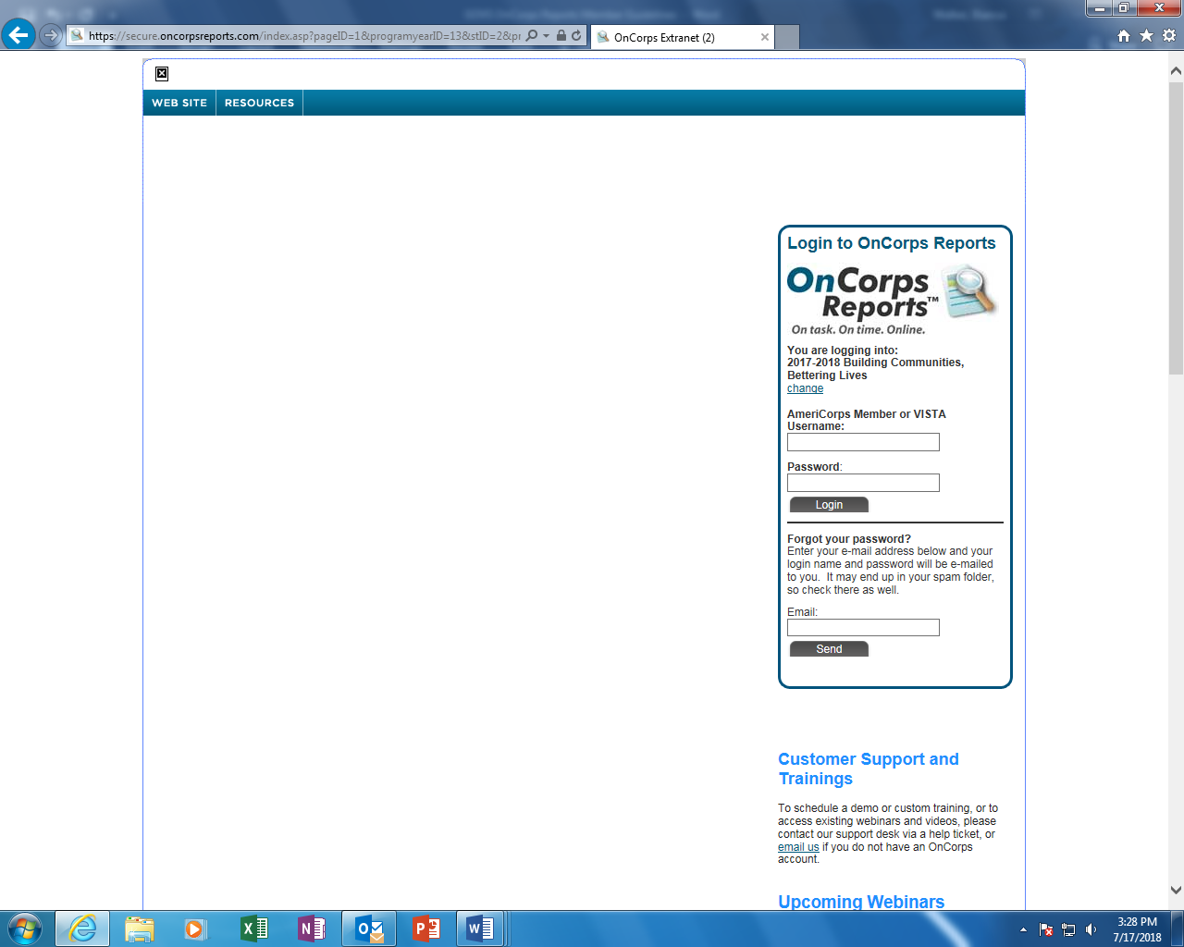
Log In using assigned Username and Password

This is the home page. The header rows cover each component within OnCorps Reports.
Header Rows
Tools
Administrative Tools–Notifications and Reminders; User Permissions for Members and Site Supervisors; Email Notifications; Timesheet Dates; Timesheet Set Up

Manage Records
Member Position Descriptions – Must be uploaded for each member.

Program Information – Information on the Program such as Name, Address, Fiscal Contact.

Service Sites – List of Service Sites.

Site Supervisors – List of Site Supervisors.

Members –Member Profile & Member Timesheets
Time Tracking
Member Timesheets
Directories
Roster of Service Sites, Supervisors and Members
Calendar
Important dates related to your program.
Help
Frequently Asked Questions, Help Request Form to contact OnCorps for assistance, Help Tutorials and Resources.
Accompaniment
According to the Community for National and Community Service (CNCS) National Service Criminal History Check (NSCHC) Guidance, accompaniment is required when an individual has access to vulnerable populations. The member must be accompanied until the program receives the results of either the state check or the FBI check. To see the full text in the National Service Criminal History Check Guidance, see attached.

For members that require accompaniment, list the days, times, first & last name of the individual(s) who accompanied them in the accompaniment section which is located at the bottom of the timesheet. If the member did not have any access to vulnerable populations during the entire timesheet period, the member can simply state “No access to vulnerable population” in the Accompaniment box. Also, if the member was cleared midweek, the member should state “Accompaniment was no longer needed (Ex.: 09/19/2018-09/21/2018)”. Time is entered in 15-minute increments. Please review the examples below.

Date | Time In | Time Out | Category | Service Site | Des./Activity | Hours
09/04/2018  Total Daily Hours  8.5 | 8:00 AM | 9:30 AM | Orientation | S.H.I.E.L.D. | Reviewed Policies & Procedures | 1.5
 | 9:30 AM | 12:30 PM | Training | S.H.I.E.L.D. | Social Justice | 3
 | 12:30 PM | 1:00 PM | Lunch | S.H.I.E.L.D. | Lunch | 0.5
 | 1:00 PM | 3:00 PM | Training | S.H.I.E.L.D. | Professional Dev. | 2
 | 3:30 PM | 5:30 PM | Service | Stark Industries | Met with clients regarding cases | 2
Totals |  |  |  |  |  | 8.5
‘Accompaniment’ is required, please note both the days, times, and full names of individuals who accompanied you:
Was accompanied by supervisor.

Comments/Description:
Strategic Homeland Intervention Enforcement Logistics Division (S.H.I.E.L.D.)

Member Name: Tony Stark, Supervisor: Nick Fury
Note: This entry is incorrect. Tony should list the days, times, & full name of the individual who accompanied him.

Date | Time In | Time Out | Category | Service Site | Des./Activity | Hours
09/04/2018  Total Daily Hours  8.5 | 8:00 AM | 9:30 AM | Orientation | S.H.I.E.L.D. | Reviewed Policies & Procedures | 1.5
 | 9:30 AM | 12:30 PM | Training | S.H.I.E.L.D. | Social Justice | 3
 | 12:30 PM | 1:00 PM | Lunch | S.H.I.E.L.D. | Lunch | 0.5
 | 1:00 PM | 3:00 PM | Training | S.H.I.E.L.D. | Professional Dev. | 2
 | 3:30 PM | 5:30 PM | Service | Stark Industries | Met with clients regarding cases | 2
Date | Time In | Time Out | Category | Service Site | Des./Activity | Hours
09/05/2018  Total Daily Hours  9 | 8:00 AM | 10:00 AM | Service | S.H.I.E.L.D. | Team Meeting | 2
 | 10:00 AM | 10:15 PM | Service | S.H.I.E.L.D. | Checked emails | 0.25
 | 10:15 AM | 12:15 PM | Service | S.H.I.E.L.D. | Typed up reports | 2
 | 12:15 PM | 1:15 PM | Lunch | S.H.I.E.L.D. | Lunch | 1
 | 1:15 PM | 4:15 PM | Service | Stark Industries | Prepared materials for summit | 3
 | 4:15 PM | 4:45 PM | Service | Stark Industries | Reviewed meeting materials | 0.5
 | 4:45 PM | 5:15 PM | Service | S.H.I.E.L.D. | Prepared memos | 0.5
 | 5:15 PM | 6:00 PM | Service | S.H.I.E.L.D. | Prepared briefing materials | 0.75
Date | Time In | Time Out | Category | Service Site | Des./Activity | Hours
09/06/2018  Total Daily Hours  8 | 8:00 AM | 10:00 AM | Service | S.H.I.E.L.D. | Team Meeting | 2
 | 10:00 AM | 12:00 PM | Training | S.H.I.E.L.D. | CPR & First Aid | 2
 | 12:00 PM | 12:45 PM | Service | S.H.I.E.L.D. | Reviewed emails/ briefing materials | 0.75
 | 12:45 PM | 1:45 PM | Lunch | S.H.I.E.L.D. | Lunch | 1
 | 1:45 PM | 3:45 PM | Training | S.H.I.E.L.D. | Disaster Preparedness | 2
 | 3:45 PM | 5:00 PM | Service | S.H.I.E.L.D. | Typed up reports; prep. for summit | 1.25
Date | Time In | Time Out | Category | Service Site | Des./Activity | Hours
09/07/2018  Total Daily Hours  11 | 8:00 AM | 10:00 AM | Service | S.H.I.E.L.D. | Team Meeting | 2
 | 10:00 AM | 11:30 PM | Service | S.H.I.E.L.D. | Prepared reports | 1.5
 | 11:30 PM | 1:30 PM | Service | S.H.I.E.L.D. | Typed reports | 2
 | 1:30 PM | 2:30 PM | Lunch | S.H.I.E.L.D. | Lunch | 1
 | 2:30 PM | 5:00 PM | Service | Stark Industries | Setup for summit | 2.5
 | 7:00 PM | 10:00 PM | Community Engagement | Stark Industries | Attended Stark Industries Summit | 3
Totals |  |  |  |  |  | 36.5
‘Accompaniment’ is required, please note both the days, times, and full names of individuals who accompanied you:
09/05/2018, 3:30-5:30 PM, Nick Fury;
09/05/2018–09/06/2018, Not around vulnerable population; 09/07/2018, 7-10 PM, Nick Fury
Comments/Description.: How to apply technology to address food insecurity & poverty (Stark Ind. Summit)
Note: Tony’s entry is partially correct. He needs to change the date on line one from 09/05 to 09/04.
Date | Time In | Time Out | Category | Service Site | Des./Activity | Hours
09/04/2018  Total Daily Hours  8.5 | 8:00 AM | 9:30 AM | Orientation | S.H.I.E.L.D. | Reviewed Policies/Procedures | 1.5
 | 9:30 AM | 12:30 PM | Training | S.H.I.E.L.D. | Social Justice | 3
 | 12:30 PM | 1:00 PM | Lunch | S.H.I.E.L.D. | Lunch | 0.5
 | 1:00 PM | 3:00 PM | Training | S.H.I.E.L.D. | Professional Dev. | 2
 | 3:30 PM | 5:30 PM | Service | Stark Industries | Met with clients regarding cases | 2
Date | Time In | Time Out | Category | Service Site | Des./Activity | Hours
09/05/2018  Total Daily Hours  9 | 8:00 AM | 10:00 AM | Service | S.H.I.E.L.D. | Team Meeting | 2
 | 10:00 AM | 10:15 PM | Service | S.H.I.E.L.D. | Checked emails | 0.25
 | 10:15 AM | 12:15 PM | Service | S.H.I.E.L.D. | Typed up reports | 2
 | 12:15 PM | 1:15 PM | Lunch | S.H.I.E.L.D. | Lunch | 1
 | 1:15 PM | 4:15 PM | Service | Stark Industries | Prepared materials for summit | 3
 | 4:15 PM | 4:45 PM | Service | Stark Industries | Reviewed meeting materials | 0.5
 | 4:45 PM | 5:15 PM | Service | S.H.I.E.L.D. | Prepared memos | 0.5
 | 5:15 PM | 6:00 PM | Service | S.H.I.E.L.D. | Prepared briefing materials | 0.75
Date | Time In | Time Out | Category | Service Site | Des./Activity | Hours
09/06/2018  Total Daily Hours  8 | 8:00 AM | 10:00 AM | Service | S.H.I.E.L.D. | Team Meeting | 2
 | 10:00 AM | 12:00 PM | Training | S.H.I.E.L.D. | CPR & First Aid | 2
 | 12:00 PM | 12:45 PM | Service | S.H.I.E.L.D. | Reviewed emails/ briefing materials | 0.75
 | 12:45 PM | 1:45 PM | Lunch | S.H.I.E.L.D. | Lunch | 1
 | 1:45 PM | 3:45 PM | Training | S.H.I.E.L.D. | Disaster Preparedness | 2
 | 3:45 PM | 5:00 PM | Service | S.H.I.E.L.D. | Typed up reports; prep. for summit | 1.25
Date | Time In | Time Out | Category | Service Site | Des./Activity | Hours
09/07/2018  Total Daily Hours  11 | 8:00 AM | 10:00 AM | Service | S.H.I.E.L.D. | Team Meeting | 2
 | 10:00 AM | 11:30 PM | Service | S.H.I.E.L.D. | Prepared reports | 1.5
 | 11:30 PM | 1:30 PM | Service | S.H.I.E.L.D. | Typed reports | 2
 | 1:30 PM | 2:30 PM | Lunch | S.H.I.E.L.D. | Lunch | 1
 | 2:30 PM | 5:00 PM | Service | Stark Industries | Setup for summit | 2.5
 | 7:00 PM | 10:00 PM | Community Engagement | Stark Industries | Attended Stark Industries Summit | 3
Totals |  |  |  |  |  | 36.5
‘Accompaniment’ is required, please note both the days, times, and full names of individuals who accompanied you:
09/04/2018, 3:30-5:30 PM, Nick Fury;
09/05/2018–09/06/2018, Not around vulnerable population
09/07/2018, 7-10 PM, Nick Fury
Comments/Description: Stark Industries Summit–Applying technology to address food insecurity, homelessness, and poverty.
Note: Tony’s entry is correct & Nick can approve this timesheet.
Lunch Break
Members are required to log a lunch break if the member serves 6 consecutive hours. Lunch breaks are only 30 minutes to an hour. If the member serves from 8:00 a.m. – 5:00 p.m., they should take a 30-minute or 1-hour lunch break. The lunch break should not be scheduled before or during the first hour of scheduled service.
In the example below, Steve at a minimum, should take a 30-minute (2:00pm – 2:30pm) or 1-hour (2:30pm – 3:30pm) lunch break before his next shift resumes. Time is entered in 15-min. increments. Please review the examples below.
Table 1
Date | Time In | Time Out | Category | Service Site | Des./Activity | Hours
09/24/2018  Total Daily Hours  8.5 | 8:00 AM | 9:00 AM | Service | S.H.I.E.L.D. | Team Meeting | 1
 | 9:00 AM | 12:00 PM | Community Engagement | S.H.I.E.L.D. | Mentored military children | 3
 | 12:00 PM | 2:00 PM | Service | S.H.I.E.L.D. | Typed memo & report on mentoring activities | 2
 | 2:00 PM | 5:00 PM | Service | S.H.I.E.L.D. | Updated client files | 2.5
Totals |  |  |  |  |  | 8.5
Member Name: Steve Rogers, Supervisor: Nick Fury
Note: Steve served 8.5 consecutive hours without taking a lunch break. This entry is incorrect.

Table 2
Date | Time In | Time Out | Category | Service Site | Des./Activity | Hours
09/24/2018  Total Daily Hours  8.5 | 8:00 AM | 9:00 AM | Service | S.H.I.E.L.D. | Team Meeting | 1
 | 9:00 AM | 12:00 PM | Service | S.H.I.E.L.D. | Mentored military children | 3
 | 12:00 PM | 2:00 PM | Service | S.H.I.E.L.D. | Typed memo & report on mentoring activities | 2
 | 2:00 PM | 2:30 PM | Lunch | S.H.I.E.L.D. | Lunch | 0.5
 | 2:30 PM | 5:00 PM | Service | S.H.I.E.L.D. | Updated client files | 2.5
Totals |  |  |  |  |  | 8.5
Member Name: Steve Rogers, Supervisor: Nick Fury
Note: Although Steve served 6 consecutive hours, he stopped and took a 30-minute lunch break before he resumed his next service activity. This entry is correct.

Lunch Break Cont.
Date | Time In | Time Out | Category | Service Site | Des./Activity | Hours
10/01/2018  Total Daily Hours  12.75 | 8:00 AM | 10:30 AM | Service | S.H.I.E.L.D. | Team Meeting | 2.5
 | 10:30 AM | 1:00 PM | Service | S.H.I.E.L.D. | Reviewed briefing materials | 2.5
 | 1:00 PM | 2:00 PM | Service | S.H.I.E.L.D. | Typed report | 1
 | 2:00 PM | 2:30 PM | Lunch | S.H.I.E.L.D. | Lunch | 0.5
 | 2:30 PM | 5:30 PM | Service | S.H.I.E.L.D. | Helped kids to study & with homework | 3
 | 5:30 PM | 8:45 PM | Extra Hours | S.H.I.E.L.D. | Assisted coaches & basketball players in practice | 3.75
Totals |  |  |  |  |  | 12.75
The member took a lunch break after serving 6 consecutive hours. However, the member served an additional 6 hours & and another break is needed. How should the member properly document this additional break? Please see the examples below.

Table 1
Member Name: Wanda Maximoff, Supervisor: Nick Fury
Note: Wanda’s entry is incorrect. Although she took a 30-minute lunch break, she served an additional 6.75 hours. Please review Table 2 below to see why that entry is correct.

Table 2

Member Name: Wanda Maximoff, Supervisor: Nick Fury
Date | Time In | Time Out | Category | Service Site | Des./Activity | Hours
10/01/2018  Total Daily Hours  12 | 8:00 AM | 10:30 AM | Service | S.H.I.E.L.D. | Team Meeting | 2.5
 | 10:30 AM | 1:00 PM | Service | S.H.I.E.L.D. | Reviewed briefing materials | 2.5
 | 1:00 PM | 2:00 PM | Service | S.H.I.E.L.D. | Typed report | 1
 | 2:00 PM | 2:30 PM | Lunch | S.H.I.E.L.D. | Lunch | 0.5
 | 2:30 PM | 5:30 PM | Service | S.H.I.E.L.D. | Helped kids to study & with homework | 3
 | 5:45 PM | 8:45 PM | Extra Hours | S.H.I.E.L.D. | Assisted coaches & basketball players in practice | 3
Totals |  |  |  |  |  | 12
Note: Wanda’s entry is correct. Although a lunch break is noted above, Wanda took a 15-minute break before resuming her next service activity at 5:45 PM. Therefore, she did not serve 6 consecutive hours without a break.

Lunch Break Cont.

Table 3

Member Name: Sam Wilson, Supervisor: Nick Fury
Date | Time In | Time Out | Category | Service Site | Des./Activity | Hours
10/06/2018  Total Daily Hours  5 | 8:00 AM | 1:00 PM | Service | S.H.I.E.L.D. | Community cleanup; removed debris & recycled materials | 5
 | 1:00 PM | 1:30 PM | Lunch | S.H.I.E.L.D. | Lunch | 0.5
Totals |  |  |  |  |  | 5
Note: Since Sam did not serve more than 6 hours, no lunch break is required.

Table 4
Member Name: Sam Wilson, Supervisor: Nick Fury
Date | Time In | Time Out | Category | Service Site | Des./Activity | Hours
10/06/2018  Total Daily Hours  5 | 8:00 AM | 1:00 PM | Service | S.H.I.E.L.D. | Community Cleanup; removed debris & recycled materials | 5
Totals |  |  |  |  |  | 5
Note: This entry is correct because Sam only served 5 hours.

Time Off
As an AmeriCorps member, you are not an employee of the organization that you serve. Therefore, you do not accrue any leave, personal, sick, vacation, or comp time off. However, when a member is absent from service, it should be noted on your timesheet. One of the following subcategories should be selected when the member is absent from service and those are: Not Scheduled, Holiday, and Leave at All Sites. Please review the details below regarding each subcategory.

Note: If you serve half a day, members should not enter a “Time Off” subcategory for the first or second half of the day that the member did not serve. The timesheet should only show the hours served.

Table 1

Member Name: Sam Wilson, Supervisor: Nick Fury
Date | Time In | Time Out | Category | Service Site | Des./Activity | Hours
10/02/2018  Total Daily Hours  4 | 8:00 AM | 10:00 AM | Service | S.H.I.E.L.D. | Team Meeting | 2
 | 10:00 AM | 12:00 PM | Service | S.H.I.E.L.D. | Reviewed briefing materials; Checked emails | 2
 | 12:00 PM | 5:00 PM | Not Scheduled | S.H.I.E.L.D. | Not Scheduled | 5
Totals |  |  |  |  |  | 4
Note: This entry is incorrect. Sam should only show the hours that he served.
Table 2

Member Name: Sam Wilson, Supervisor: Nick Fury
Date | Time In | Time Out | Category | Service Site | Des./Activity | Hours
10/02/2018  Total Daily Hours  4 | 8:00 AM | 10:00 AM | Service | S.H.I.E.L.D. | Team Meeting | 2
 | 10:00 AM | 12:00 PM | Service | S.H.I.E.L.D. | Reviewed briefing materials; Checked emails | 2
Totals |  |  |  |  |  | 4
Note: This entry is correct. Sam only shows the hours he served.

Not Scheduled
This category will be used for two purposes. First, all members should only use this category in the event of inclement weather.

Member Name: Sam Wilson, Supervisor: Nick Fury
Date | Time In | Time Out | Category | Service Site | Des./Activity | Hours
10/03/2018 | 8:00 AM | 5:00 PM | Not Scheduled | S.H.I.E.L.D. | Inclement Weather | 0
Totals |  |  |  |  |  | 0
Note: The second purpose only applies to members who do not serve Full-Time. Non-full-time members will select this option if they are not scheduled to serve at their service site even if their site was operating that day. For example, Sam Wilson will serve 300 hours which does not require him to serve Monday–Friday, 8AM-5PM. In other words, Sam is not required to report for service every day.

Member Name: Sam Wilson, Supervisor: Nick Fury
Date | Time In | Time Out | Category | Service Site | Des./Activity | Hours
10/03/2018 | 8:00 AM | 5:00 PM | Not Scheduled | S.H.I.E.L.D. | Not Scheduled | 0
Totals |  |  |  |  |  | 0

Holiday
Members should only use this category when the member is not serving a full day due to the service site and/or program office is closed for a holiday such as Labor Day, Columbus Day, Veteran’s Day, Thanksgiving, winter break, Christmas, New Year’s, MLK Day, spring break, & 4th of July.

Member Name: T’Challa, Supervisor: Zuri
Date | Time In | Time Out | Category | Service Site | Des./Activity | Hours
11/21/2018  Total Daily Hours  4 | 8:00 AM | 10:30 AM | Service | Wakanda | Assisted with packing supplies for food distribution | 2.5
 | 10:30 AM | 12:00 PM | Service | Wakanda | Typed report | 1.5
Date | Time In | Time Out | Category | Service Site | Des./Activity | Hours
11/22/2018  Total Daily Hours  0 |  |  | Holiday | Wakanda | Holiday | 0
Date | Time In | Time Out | Category | Service Site | Des./Activity | Hours
11/23/2018  Total Daily Hours  0 |  |  | Holiday | Wakanda | Holiday | 0

Leave at All Sites
Members should only use this category when the member is not serving a full day due to personal reasons such as doctor appointments, sick, vacation, etc.

Member Name: T’Challa, Supervisor: Zuri
Date | Time In | Time Out | Category | Service Site | Des./Activity | Hours
01/10/2019 |  |  | Leave at All Sites | Wakanda | Leave at All Sites | 0
OnCorps Reports–Additional Timesheet Categories

Pre-Service Training
Some programs have members complete hands-on training during the beginning of the service year. These hours appear to be service activities based on the description entered by the member. This results in the questioning of whether the hours are service or training when timesheets are reviewed. To alleviate any confusion, members should use the category, “Pre-Service Training” to document these hours.

Orientation
Members should complete orientation within their first 30 days of service. This sub-category should be used by members when they are completing program orientation training.

Outside Service
To earn extra service hours, members can perform “outside service” at sites that are pre-approved by the member’s program. Members will use this category when they serve extra hours outside of their service site/host organization. Note: Although these extra service hours can be earned at approved locations outside of the host organization, the hours earned must be within the scope of the grant.

