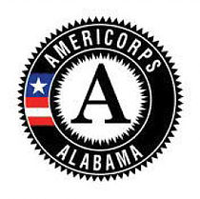
NATIONAL DAYS OF SERVICE
Day of Service/Special Initiative
Preliminary Report

AmeriCorps Program Name:

Service Project Description:
(What is the project?)

Goal of the Service Project:
(What do you hope to achieve?)

Overall Purpose of the Service Project:
(Why is this project needed?)

Focus Area:

- Service Project Date:

- Service Project Time:

- Service Project Location (Venue):

- Service Project City and State:

- Contact Person’s Name and Email:

- Estimated Number of Those Who Will be Impacted:

- Estimated Number of Volunteers:

- Estimated Number of Volunteer Hours:

- Estimated Number of VIP’s:

- Planned Press Releases/Social Media: Planned press release and social media posts are developing on the opportunity to give, planned day of service and impact of giving.

  - Check the Branding and Messaging Guidance for the appropriate hashtags/handles

