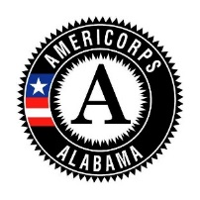
AMERICORPS PROGRAM SPOTLIGHT
Instructions
- Complete each section below with gray text. Once you have completed this form, please return it to Jade.Gantt@servelabama.gov.
- Pictures: Each spotlight is to be accompanied with a picture of the program staff. If you would like to include pictures of other key staff, including the Financial Director, Executive Director, Site Supervisors, etc. that’s perfectly okay, but program staff need to be in the picture.
  - Please wear an AmeriCorps pin or button or gear and make sure it is visible.
  - Please don’t photo shop AmeriCorps logos onto the picture.
  - Please list all the people in the picture and their title.
  - Pictures must be a JPEG image. Images saved on a word document will not be accepted.
    - When saving the title of the image, please save it as the following: Program Staff-AIST-2020-21.
- If you have any questions, please let us know.

Legal Applicant/Host Organization’s Name

AmeriCorps Program Name

AmeriCorps Program Staff Names and Titles

Counties of Service

3-4 Sentences – Describe your AmeriCorps program

Number of Members Serving

3-4 Sentences – Responsibilities of the Members

3-4 Sentences – What the members and the program hope to accomplish by the end of the program year

